Technical Assistance for Turkey in Horizon 2020 Phase-II
EuropeAid/139098/IH/SER/TR
Turkish National Infoday & International Brokerage Event on
Clean Hydrogen Partnership 2024 Call
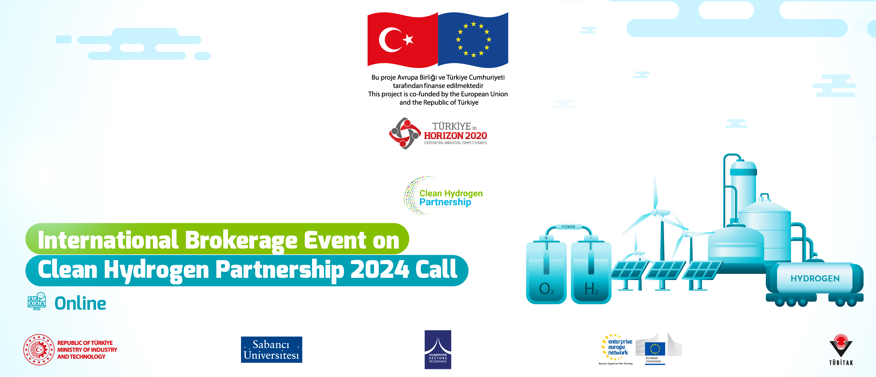
Organized by the “Turkey in Horizon 2020-Phase II” Technical Assistance Project &
TÜBİTAK National Coordination Office for EU Framework Programmes in cooperation with Sabancı University
The Agenda
30 January 2024
09:15-09:30 | Registration
09:30-11:30 | Welcome Addresses  Çağrı YILDIRIM, Horizon Europe National Coordinator of Türkiye  General Information on Clean Hydrogen Partnership 2024 call (Turkish)  Hydrogen Europe (TBC)  TÜBİTAK Support for the Membership to the Networks (Turkish)  H2MAC Project Presentation, Muharrem YAZICI, Excavator Engineering Manager, Hidromek  ECOHYDRO Project Presentation, Nihan CIN, R&D Section Manager, TEMSA  Hydrogen Valleys Highlights  Question and Answers
11:30-11:40 | Coffee Break
11:40-12:30 | Pitching Workshop (English)
12:30-12:40 | B2Match Guideline and EEN Introduction
12:40-13:30 | Lunch Break
13:30-18:30 | One-to-one Meetings through B2Match Platform

